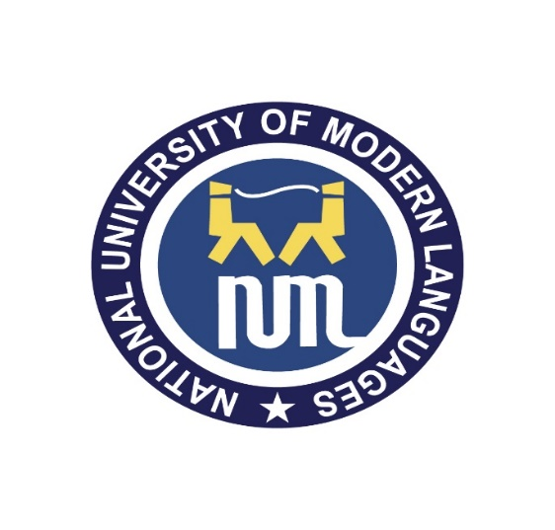
Assignment # 01
Topic: “Truth Table”
Submitted to: Ms.Anam Ashraf
Submitted by: Zulqarnain Hassan
Roll No: 21379
Section: A
Semester: Second
Dated: 22 Sep 2022

Department of Software Engineering, National University of Modern Languages, Islamabad
Fall, 2022

